 | Pimpri Chinchwad Education Trust’s  Pimpri Chinchwad College of Engineering
Experiment 6
Experimentation details
Department: E&TC Academic Year: 2025-26 Semester-I
Class: B.Tech E&TC Course: VLSI Design Lab

Name:

Div and batch:

Roll No:

Title of the Experiment:
Model and verify 4-bit Universal shift using VHDL and implement on FPGA and evaluate power and timing performance

Software Requirements: Xilinx 14.7 ISE Design Suite
Hardware Requirements: Xilinx Spartan-6 XC6SLX45 FPGA

VHDL Code for Simulation
library IEEE;
use IEEE.STD_LOGIC_1164.ALL;
use IEEE.STD_LOGIC_arith.ALL;
use IEEE.STD_LOGIC_unsigned.ALL;
entity usr is
Port ( Clk, rst, sin : in STD_LOGIC;
m : in STD_LOGIC_VECTOR (1 downto 0);
pin : in STD_LOGIC_VECTOR (3 downto 0);
sout : out STD_LOGIC;
pout : out STD_LOGIC_VECTOR (3 downto 0));
end usr;
architecture Behavioral of usr is
signal p1,p2:std_logic_vector(3 downto 0);
signal s1:std_logic;
begin
process(clk,rst,pin,sin,m)
begin
if(rst='1') then
p1<="0000";
p2<="0000";
s1<='0';
elsif (clk'event and clk='1') then
if(m="00") then --SISO
p1(0)<=sin;
p1(1)<=p1(0);
p1(2)<=p1(1);
p1(3)<=p1(2);
s1<=p1(3);

elsif(m="01") then --SIPO
p1(0)<=sin;
p1(1)<=p1(0);
p1(2)<=p1(1);
p1(3)<=p1(2);
p2<=p1;
elsif(m="10") then --PIPO
p1<=pin;
p2<=p1;
else --PISO
p1<=pin;
s1<=p1(3);
end if;
end if;
end process;
pout<=p2;
sout<=s1;
end Behavioral;

RTL Schematic
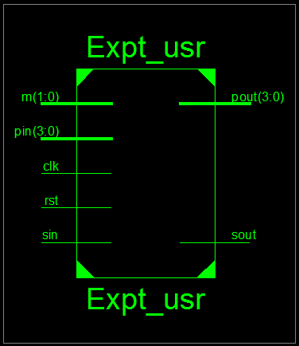
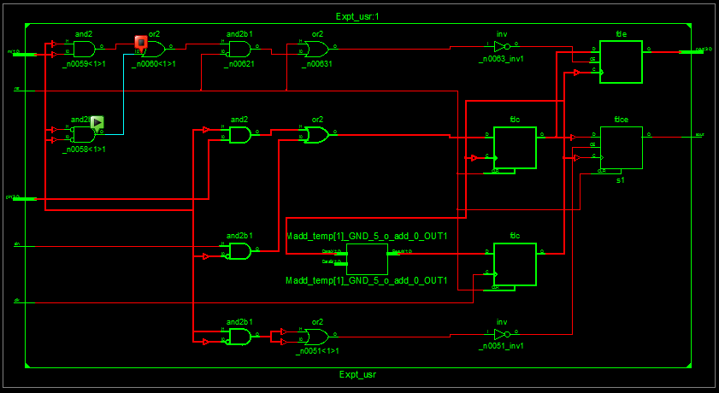
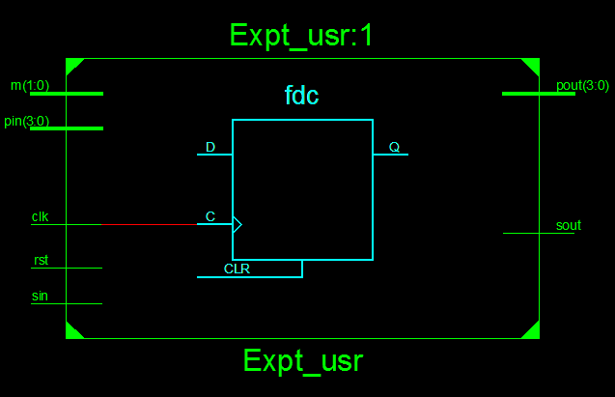
VHDL Test Bench
LIBRARY ieee;
USE ieee.std_logic_1164.ALL;

-- Uncomment the following library declaration if using
-- arithmetic functions with Signed or Unsigned values
--USE ieee.numeric_std.ALL;

ENTITY usr_tb IS
END usr_tb;

ARCHITECTURE behavior OF usr_tb IS

-- Component Declaration for the Unit Under Test (UUT)

COMPONENT usr
PORT(
Clk : IN std_logic;
rst : IN std_logic;
sin : IN std_logic;
m : IN std_logic_vector(1 downto 0);
pin : IN std_logic_vector(3 downto 0);
sout : OUT std_logic;
pout : OUT std_logic_vector(3 downto 0)
);
END COMPONENT;
--Inputs
signal Clk : std_logic := '0';
signal rst : std_logic := '0';
signal sin : std_logic := '0';
signal m : std_logic_vector(1 downto 0) := (others => '0');
signal pin : std_logic_vector(3 downto 0) := (others => '0');

--Outputs
signal sout : std_logic;
signal pout : std_logic_vector(3 downto 0);

-- Clock period definitions
constant Clk_period : time := 20 ns;

BEGIN

-- Instantiate the Unit Under Test (UUT)
uut: usr PORT MAP (
Clk => Clk,
rst => rst,
sin => sin,
m => m,
pin => pin,
sout => sout,
pout => pout
);

-- Clock process definitions
Clk_process :process
begin
Clk <= '0';
wait for Clk_period/2;
Clk <= '1';
wait for Clk_period/2;
end process;
rst_process :process
begin
rst <= '1';
wait for Clk_period;
rst <= '0';
wait;
end process;

-- Stimulus process
stim_proc: process
begin
pin<="1001";
sin<='1';
m<="00”; -- SISO
wait for 120 ns;

pin<="1101";
sin<='1';
m<="01"; -- SIPO
wait for 120 ns;

pin<="1101"; --PIPO
m<="10";
wait for 120 ns;

pin<="0100"; -- PISO
m<="11";
wait;
end process;
END;

Simulation Results
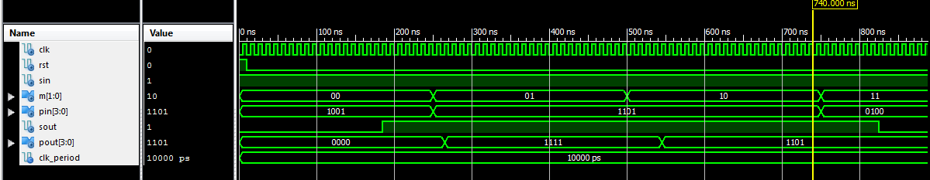
VHDL Code for Implementation
Plz note:
1. Clock freq of board= 8MhZ. So, a process is added to generate a slow clock of freq = 1 Hz
2. for slowing down the clk from 8 MHz to 1 Khz, a temp counter of size 23 bits is
introduced for generating delay

VHDL Code:

library IEEE;
use IEEE.STD_LOGIC_1164.ALL;
use IEEE.STD_LOGIC_arith.ALL;
use IEEE.STD_LOGIC_unsigned.ALL;
entity usr is
Port ( Clk,rst,sin : in STD_LOGIC;
m : in STD_LOGIC_VECTOR (1 downto 0);
pin : in STD_LOGIC_VECTOR (3 downto 0);
sout : out STD_LOGIC;
pout : out STD_LOGIC_VECTOR (3 downto 0));
end usr;

architecture Behavioral of usr is
signal p1,p2:std_logic_vector(3 downto 0);
signal s1:std_logic;
signal temp:std_logic_vector(22 downto 0);
signal sclk:std_logic;
begin
p11: process(clk,rst)
begin
if(rst='1')then temp<=(others=>'0');
elsif(clk'event and clk='1') then
temp<= temp + 1;
end if;
end process;
sclk<=temp(22);

p22:process(sclk,rst,pin,sin,m)
begin
if(rst='1') then
p1<="0000";
p2<="0000";
s1<='0';
elsif (sclk'event and sclk='1') then
if(m="00") then --SISO
p1(0)<=sin;
p1(1)<=p1(0);
p1(2)<=p1(1);
p1(3)<=p1(2);
s1<=p1(3);
elsif (m="01") then --SIPO
p1(0)<=sin;
p1(1)<=p1(0);
p1(2)<=p1(1);
p1(3)<=p1(2);
p2<=p1;
elsif(m="10") then --PIPO
p1<=pin;
p2<=p1;
else --PISO
p1<=pin;
s1<=p1(3);
end if;
end if;
end process;
pout<=p2;
sout<=s1;
end Behavioral;

Implementation Constraint File (UCF File)
NET "CLK" LOC = "L15"; # Bank = 1, Pin name = IO_L42P_GCLK7_M1UDM, Type = GCLK, Sch name = GCLK

# onBoardLeds
NET "pout<0>" LOC = "U18"; # Bank = 1, Pin name = IO_L52N_M1DQ15, Sch name = LD0
NET "pout<1>" LOC = "M14"; # Bank = 1, Pin name = IO_L53P, Sch name = LD1
NET "pout<2>" LOC = "N14"; # Bank = 1, Pin name = IO_L53N_VREF, Sch name = LD2
NET "pout<3>" LOC = "L14"; # Bank = 1, Pin name = IO_L61P, Sch name = LD3
NET "Sout" LOC = "M13"; # Bank = 1, Pin name = IO_L61N, Sch name = LD4
# onBoard SWITCHES
NET "pin<0>" LOC = "A10"; # Bank = 0, Pin name = IO_L37N_GCLK12, Sch name = SW0
NET "pin<1>" LOC = "D14"; # Bank = 0, Pin name = IO_L65P_SCP3, Sch name = SW1
NET "pin<2>" LOC = "C14"; # Bank = 0, Pin name = IO_L65N_SCP2, Sch name = SW2
NET "pin<3>" LOC = "P15"; # Bank = 1, Pin name = IO_L74P_AWAKE_1, Sch name = SW3
NET "sin" LOC = "P12"; # Bank = 2, Pin name = IO_L13N_D10, Sch name = SW4
NET "rst" LOC = "R5"; # Bank = 2, Pin name = IO_L48P_D7, Sch name = SW5
NET "m<0>" LOC = "T5"; # Bank = 2, Pin name = IO_L48N_RDWR_B_VREF_2, Sch name = SW6
NET "m<1>" LOC = "E4"; # Bank = 3, Pin name = IO_L54P_M3RESET, Sch name = SW7

Hardware Snapshots
Digilent ATLYS Spartan 6 FPGA Board

